How to import your data into SQLiteStudio

1. Create a new database.  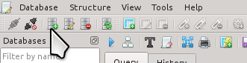 | 2. Choose a file in which to save it.  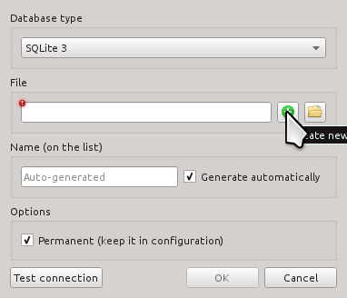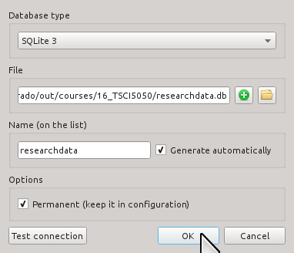
3. Choose 'Import' from the Tools menu.  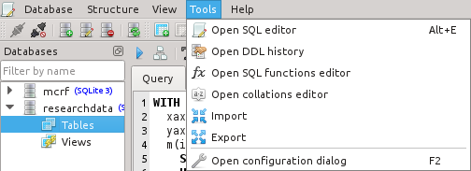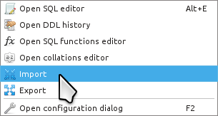 | 4. Create a new table to import into.  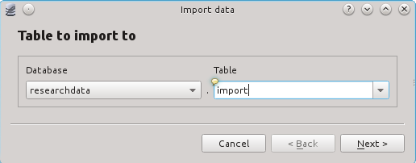
5. Select a CSV file, and make sure to che the “First line...” box. Your file might use something other than commas (tabs are a commonly used field separator). If your data looks weird, try again with a fresh table and choose a different field separator.  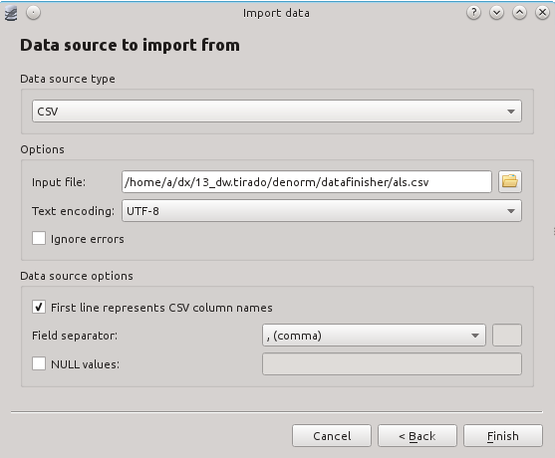 | You now have a database you can use to manage your research data!  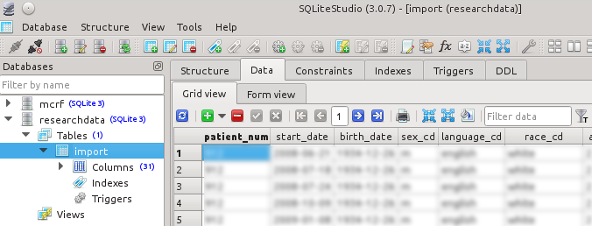

Alex F. Bokov, Creative Commons Attribution Share-Alike, 2016

